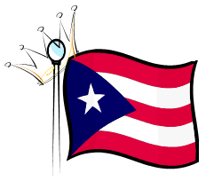

The Queen’s Court Pageant is for Members of House of Puerto Rico San Diego.

Girls must be between the ages of 10 – 21 years old in order to participate.

Learn about the House of Puerto Rico San Diego’s youth program and the House of Pacific Relations Queens Program.

Jose Lopez – Youth Program Coordinator   
(619) 252-3750

Queens Court Committee:

ivette Hector (619)397-0812  
Dee Flores (619)397-4802

# House of puerto rico san diego

# **Queen’s Court Pageant**

**Informative Meeting and Registration**

## July 30, 12:00 p.m.

### Hall of Nations, San Diego, CA

2191 West Pan American Rd  
San Diego, CA 92101